RPS Payment process

Monthly payments

Monthly payments are produced in the middle of every month on bulk cycle date. There isn’t a special job for these, when ABCD350 runs on bulk cycle date, the payments will automatically be raised and the next action date set to the next bulk cycle date.

For each payment due, an 03 (payment) record is created in AUADMOUT. Not that the field CHECK-STOCK is set to AB (or BD for the Swift payments). Daily payments are set to ET, this is how you can tell the difference between bulk cycle payment and daily payment.

Job ABCD380 splits the payment records from this file and writes them to CFGIBS.LA00.XXX.AUPAYRCD(+1).

Job ABCD387 combines the payments at client level. To combine payments where a client has more than one policy, these fields must all match:
- Payee client number
- Payee id
- Bank branch
- Bank acc number
- Acc type

ABCD389 splits CFGIBS.LA00.SRT.COMPYT into two files, CFGIBS.LA00.SRT.CHKFIL and CFGIBS.LA00.SRT.LAEFTACB. The CHK file is used in a later job for accounting totals, but also has the policies with credit card details, these are extracted in the next step.

ABCD390 splits the credit card payments from CHKFIL into a separate file and merges this file with LAEFTACB.

ABCD500 splits CFGIBS.LA00.XXX.LAEFTACB into three EFT files for the three different companies i.e. 01, 02 and 05. This isn’t necessary anymore since the PSD9 changes, but I left this jobs as is and combine the files again in the next job. All the monthly payments

(AB) are split to an ACB file. EFTFAIL is also produced here when there is a missing payee name, a report is sent to the server, but I don’t think servicing are looking at it. Maybe we should add ABCD500B to send them an email when there is something in the file. Missing payee name is usually because the payee client id was wrong when the payment was raised.

In EFTFAIL policy may come because of blank payee name or check the client number on the payment. All the restarted payments should have correct client number.

ABCD510 copies the ACBWRK file from ABCD500 to the bucket file.

XLAM510 processes the ACB bucket file – this job runs two days after bulk cycle. The file is split into SATOSA, SATONAM, NAMTONM and NAMTOSA files. The split is done according the bank branch code on each payment record, there is a table of Namibian branch codes that’s used for this. The SATOSA file is processed further in this jcl and put in Nedbank CPS format, output file CFGIBS.LA00.XXX.NED2265.BULK.

XLAM511 sends the NED2256.BULK file to Nedbank.

XLAM512 copies the ACK. NCK and DUP files to GDGs and processed the ACK file.

XLAM512A sends the rejection report to the server.

XLAM524 – start of the process of sending the other 3 payment files. Runs 2nd last working day of each month. The client numbers are extracted and a GCS call done to get client info. This is needed for across border payments and we need the latest client info.

XLAM525 – reads the GCS client file and creates a VSAM file.

XLAM526 – creates NAM to NAM file and NAM to SA files for Standard Bank Namibia (CFGIBS.LA00.XXX.STDNAM1 and CFGIBS.LA00.XXX.STDNAM2). Creates the SA to NAM file for Nedbank SA (this file is HTML format) - CFGIBS.LA00.XXX.NEDNAM

XLAM518 – sends the STDNAM1 file to Standard bank Namibia.

XLAM518A – copies the interim audit file received from STD NAM to a GDG.

XLAM519 – sends the STDNAM2 file to Standard bank Namibia.

XLAM519A – copies the interim audit file received from STD NAM to a GDG.

XLAM520 – sends the NEDNAM file to Nedbank.

XLAM520A – copies the technical file received from Nedbank to a GDG
XLAM520B – copies the status file received from Nedbank to a GDG.

XLAM521 – copies the Standard NAM final audit file to GDG. Triggered by file placement.
XLAM522 – copies the Standard NAM unpaid file to GDG. Triggered by file placement.
XLAM523 – copies the Nedbank status file to GDG. Triggered by file placement.

Daily payments

Daily payments follow the same process as above, up to ABCD500.

ABCD501 reads the three EFT files created in ABCD500 and combines them into one file - CFGIBS.LA00.XXX.EFTALL. This file is then split into the four payment files according to company, case and bank branch code. Daily payment files are then created for each of these files.

ABCD511 sends the SA to SA payments to Nedbank.
ABCD512 copies the ACK, NCK and DUP files to GDGs and processes the ACK file.
ABCD512A copies the rejection file to the server
ABCD512B sends an email to Chantal’s team to notify them if there are any rejections.
ABCD512C sends an email to CBA if all 3 files are empty.

ABCD513 sends the NAM to NAM file to STD NAM.
ABCD513A processes the interim audit file
XLAB513B processes the final audit file

ABCD514 sends the NAM to SA file to STD NAM.
ABCD514A processes the interim audit file
XLAB514B processes the final audit file

ABCD515 sends the SA to NAM file to Nedbank SA.
ABCD515A processes the interim audit file
XLAB515B processes the final audit file

Payment Queries – steps to follow
- Check the date of payment on RPG1 to make sure you are looking at the correct date.
- Check the daily payment report for that day.
- Check the ACK file that day.
- If it’s there, send a snip of the ACK file using file-aid
- If it’s not there, check the NCK and DUP files
- If all three files are empty, send an email to Host To Host Client Service h2hcs@nedbank.co.za. In the subject line put ‘Query on profile 2256’. In the message ask them to please check for ACK, NCK & DUP response files for the date in question.
- If necessary eg. File was rejected, create payment records.

Case 1 -> If all 3 files (ack, nck, dup) are empty then check CFGIBS.LA00.XXX.NED2256.ACK.F
might be the case (batch overran into Saturday, when our job ran to read the ACK.F file it was empty. The bank only sent the response later on Saturday). In this case no action required bcz payment already got processed.
Case 2 -> If all 3 files (ack, nck, dup) are empty and no data in .REJ file and NED2256.ACK.F as well, then check, all Job run, , ABCD511, ABCD512 if all steps ran fine. Check ABCD501 if it created the file or not, in 1 case same policy were present in previously in file means batch overran. In this case no action required, because there was no payment to get processed in last night run.

Files to check – bulk cycle

- SAtoSA
  - File sent to Nedbank – CFGIBS.LA00.XXX.NED2265.BULK
  - ACK file - CFGIBS.LA00.XXX.NED2256.ACK (Copy book LACPS2)
  - NCK file - CFGIBS.LA00.XXX.NED2256.NCK
  - DUP file - CFGIBS.LA00.XXX.NED2256.DUP

- NAMtoNAM
  - File sent to Standard Bank - CFGIBS.LA00.XXX.STDNAM1
  - Interim audit file - CFGIBS.LA00.XXX.STDNAM.INTAUD
  - Final audit file - CFGIBS.LA00.XXX.STDNAM.FINAUD

- NAMtoSA
  - File sent to Standard Bank - CFGIBS.LA00.XXX.STDNAM2
  - Interim audit file - CFGIBS.LA00.XXX.STDNAM.INTAUD
  - Final audit file - CFGIBS.LA00.XXX.STDNAM.FINAUD

Both NAM files use the same INTAUD and FINAUD files.

Policy number is not present on these files, you need to trac<TOTH 6842195
e the record using the sequence number in the payment file.

Using Rowan’s query on policy 80037090 – this is a NAM policy with NAM bank account. Find the policy on the STDNAM1 file for the June payments. The number to the left of OMLACNAM is the sequence number.

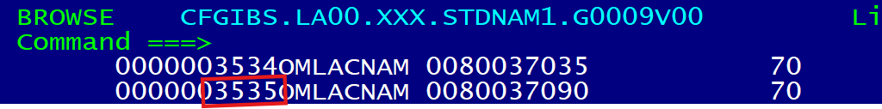

Find the correct FINAUD file for that run. Because STDNAM1 and STDNAM2 use the same FINAUD file, take note of the run number at the top of the STDNAM1 file:

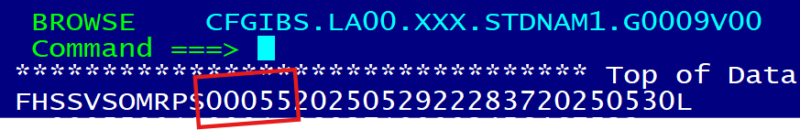

Correct FINAUD file:

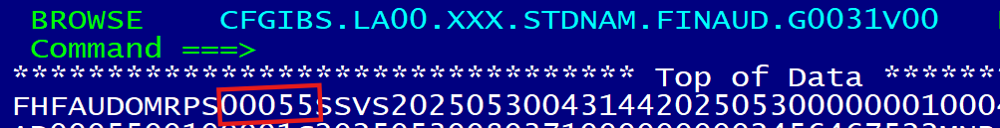

Search for the sequence number found for the payment being queried:

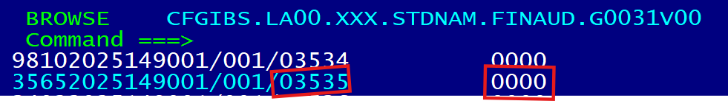

The 4 digit number to the right of the sequence number is the error code. 0000 means successful.

Page to the left to make sure you are looking at the correct record, compare name and bank account.

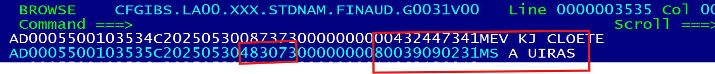
This matches, the payment was accepted by the bank, nothing more we can check.
in case we wants to check any unpaid record which has been rejected by std bank we can check below file.
CFGIBS.LA00.XXX.STDNAM.UNPAID.*
Policy number will not be available in this file

- SAtoNAM
  - File sent to Nedbank - CFGIBS.LA00.XXX.NEDNAM
  - Status file - CFGIBS.LA00.XXX.NED2256B.STATUS

Note – these files are in html format. Luckily the policy number is in the status file, so it does make it easy to check. If there is a query on one of these policies, find the status file matching date of payment. Note – sometimes we get more than one status file, look at the last one for the date in question.

What to look for – search for the policy number. There are normally 2 records for each policy.

1st record
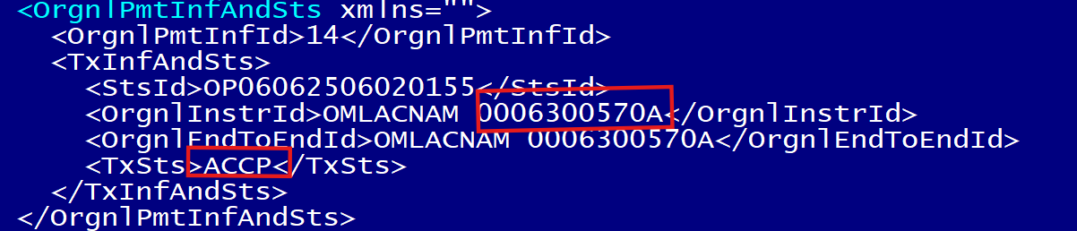

2nd record
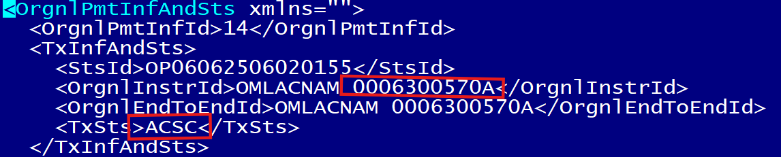

Status ACCP = accepted for processing
Status ACSC = accepted and settlement complete

If you see both of these, the payment was sent through successfully.

If you see status = RJCT this means the payment was rejected. A reason is given for the rejection:

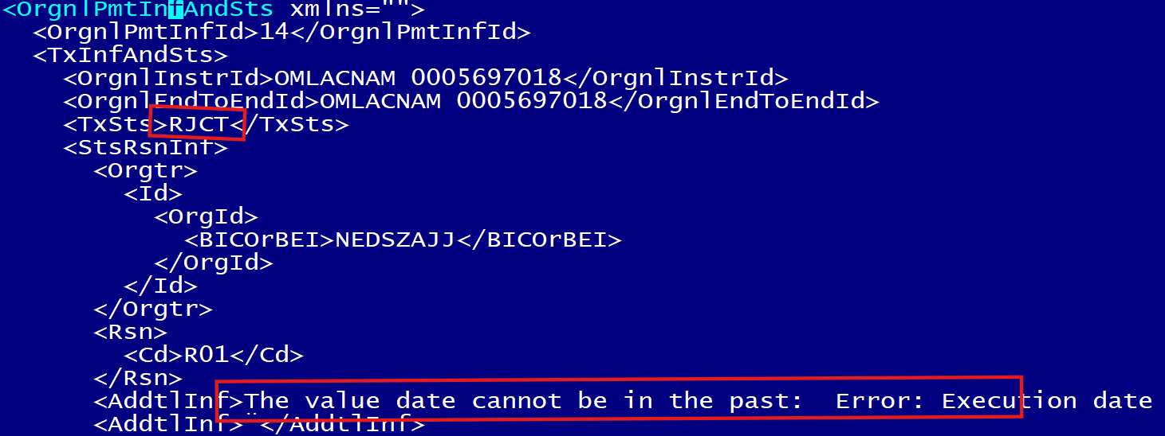

Files to check – daily payments

- SAtoSA
  - File sent to Nedbank – CFGIBS.LA00.XXX.NED2256.DAILY
  - ACK file - CFGIBS.LA00.XXX.NED2256.DAILY.ACK
  - NCK file - CFGIBS.LA00.XXX.NED2256.DAILY.NCK
  - DUP file - CFGIBS.LA00.XXX.NED2256.DAILY.DUP

- NAMtoNAM
  - File sent to Standard Bank - CFGIBS.LA00.XXX.STDNAM1.DAILY
  - Interim audit file - CFGIBS.LA00.XXX.STDNAM.INTAUD.DAILY
  - Final audit file - CFGIBS.LA00.XXX.STDNAM.FINAUD

- NAMtoSA
  - File sent to Standard Bank - CFGIBS.LA00.XXX.STDNAM2.DAILY
  - Interim audit file - CFGIBS.LA00.XXX.STDNAM.INTAUD.DAILY
  - Final audit file - CFGIBS.LA00.XXX.STDNAM.FINAUD

- SAtoNAM
  - File sent to Nedbank - CFGIBS.LA00.XXX.NEDNAM.DAILY
  - Status file - CFGIBS.LA00.XXX.NED2256B.STATUS

How to create payment records:
How to identify issues:
Check the file below for issue date-> in this case
We check the daily file for 15th and found the policy number
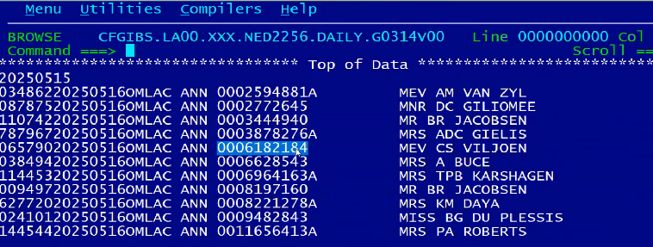
Next to check the file below for 15th and we found the error policy there.
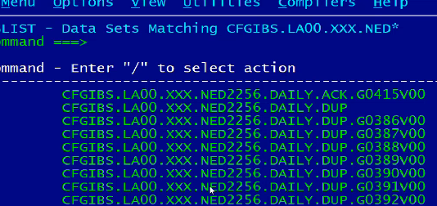

When payment is created it is creating credit in LL145, that credit will get cleared by when it goes through bank and account back as debit on bank statement.
We have sent it to the bank it gone to ll145 but the bank is not process so has not come back from bank so still in LL145.

So just to clear LL145 we will create payment-> follow the steps below.

We need to add payment to the latest version of the file below.
First of all, copy the CFGIBS.**.LAEFTACB file into latest version of PSTIBS.LA00.XXX.LAEFTACB.G0603V00
Verify all details from daily report EFTACB

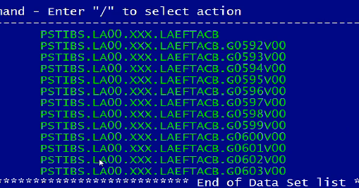
This file will get picked up in ABCD390

Always update this file in file-ad -> copybook CICPIBS.VRTOMA0.COPYLIB(CRAD0392)
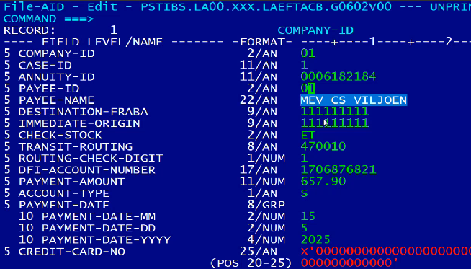
Make sure to update above filed correct.
- Correct policy number
- Payee id
- Payee Name
- Destination-origin will always be same
- Immediate origin will always be same
- Check-stock will be ET
- Transit routine is branch code double check from daily file
- Routing-check-digit will be 1
- Account number
- The payment amount should be correct (we can verify from daily report)
- Payment Date- always put the original payment date (we can check in daily file)
Create file and get it reviewed by someone.

If we get query for Proof of payments- ACK file is our only proof of payment
don't send this to brokers, we only send these screen shots to our internal servicing teams.
**************************************************************************
Reference query : CBA9752844
Query: If dup file having data saying policy rejected due to duplicate error.
drop an email to H2H and check for correct sequence number.
Solution: if the sequence number goes out of synch again, hard code LABCPSD1 the new number in the program.
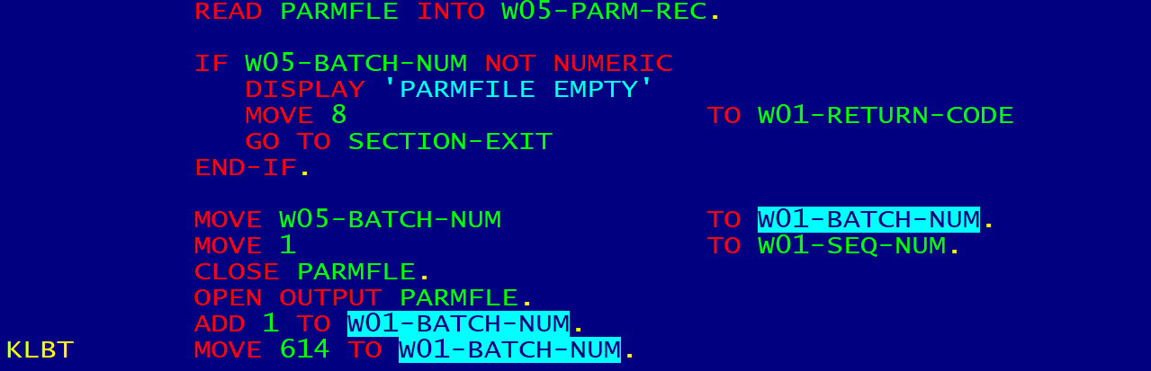
update load in JCL and point jcl from override lib and next day check if payment went through and sequence also updated correctly.
Rise RITM for scheduling and release management to copy below jcl
IPS.KLB.JCL(ABCD501) and point it from override jcl
also copy payments from last night to the PSTIBS file.

**********************************************************************************
CBA9759486 - > RPS Daily Payments - NO RESPONSE FROM NEDBANK
InEFTALL file there were 1 policy,
investigation: Policy was 01, 5 Case, sa policy with Namibian bank details.
so after successful process of payment, IT went to standard bank Namibia not Nedbank, that’s why we got NO RESPONSE FROM NEDBANK trigger email with with all 3 file as empty although there were 1 policy payment that goes process
